**In Class Assignment**

Brian Webb – ID: 34775506

Student

CSC120-10187: Digital Design Fundamentals

Dinesh Sthapit / Carlos Rodriguez

May 8, 2022

Login Page Mockup

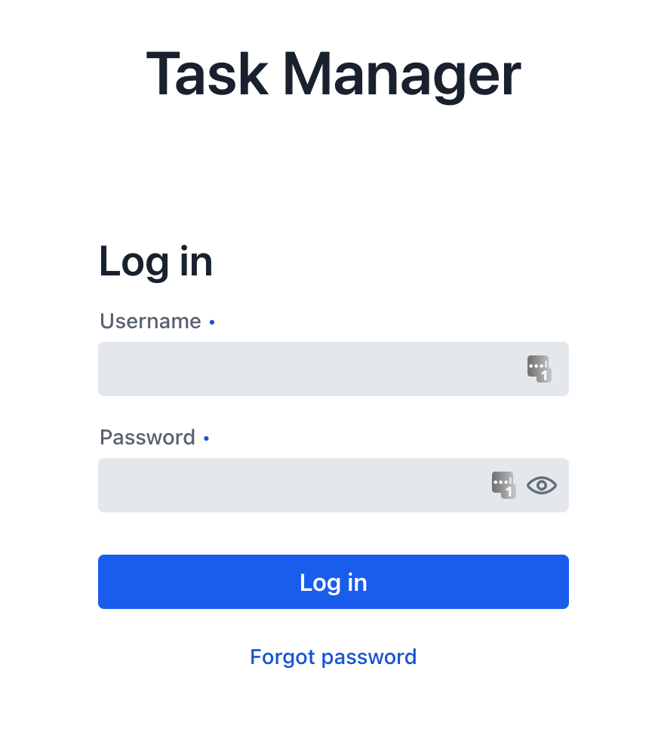

Tasks Page

Tasks Table

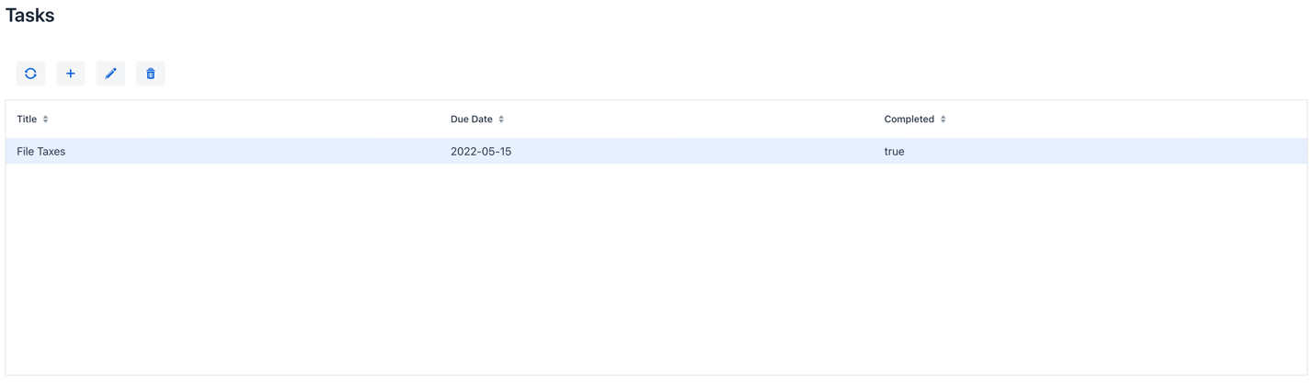

Add Modal

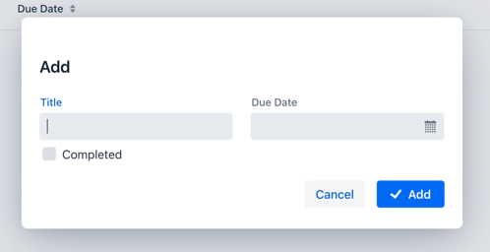

Update Modal

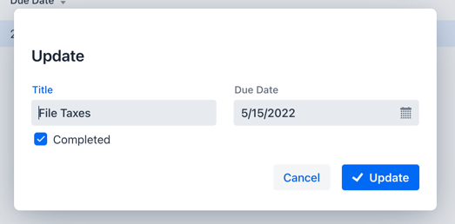

Delete Modal

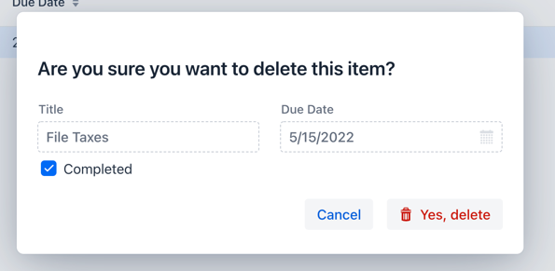

HTML

Because I am using Vaadin, this was auto generated. The Vaadin view code also provided here.

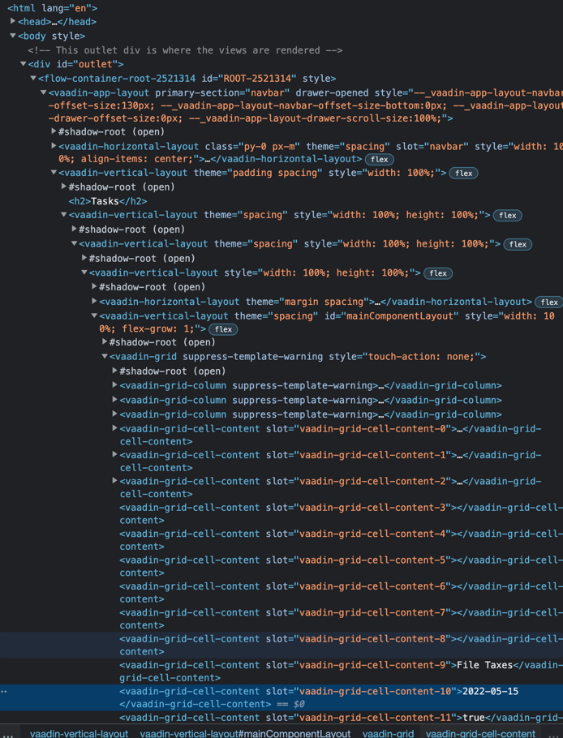

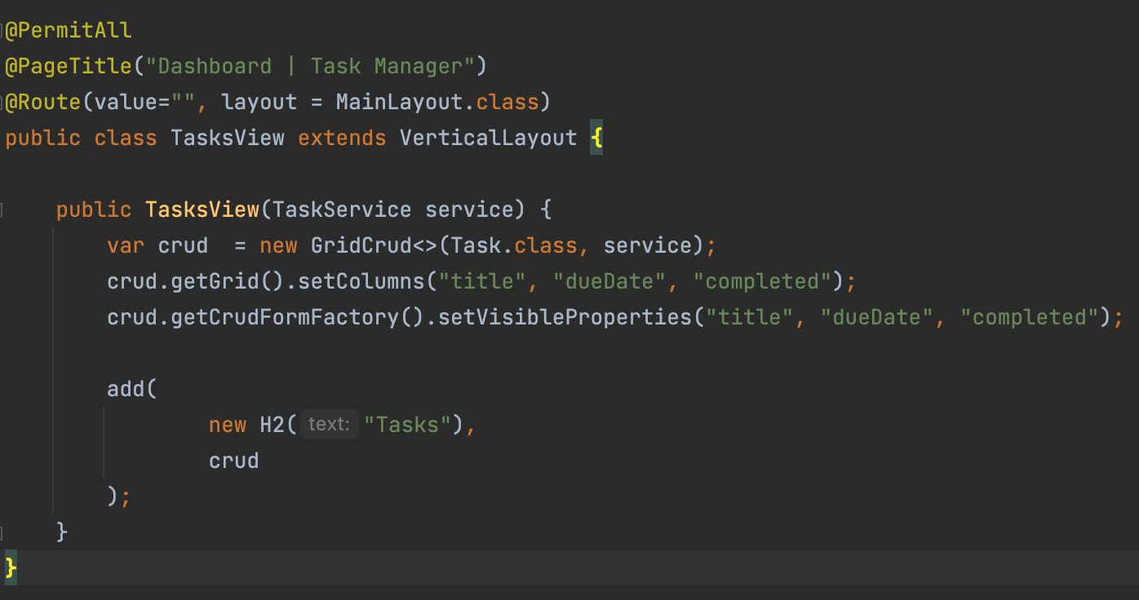

Source Control

I am doing this project alone, but am using git anyway. I use GitKraken as a visual Git software.

